**Packet Tracer - OSPF vs EIGRP**

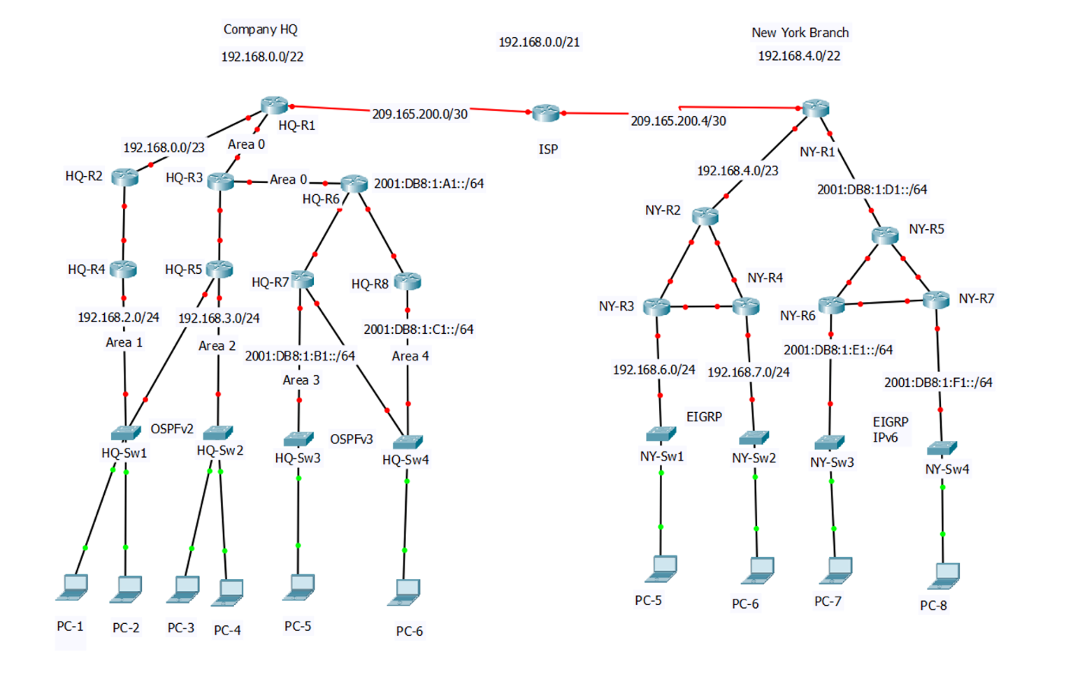

**ISP (Already Configured) IPv4 and IPv6**

|  |  |  |  |
| --- | --- | --- | --- |
| **Device** | **Interface** | **IPv4 Address** | **Subnet Mask** |
| ISP | S0/0/0 | 209.165.200.1 | 255.255.255.252 |
| S0/0/1 | 209.165.200.5 | 255.255.255.252 |

**Company HQ (OSPFv2 IPv4)**

|  |  |  |  |  |
| --- | --- | --- | --- | --- |
| **Device**  **(Area)** | **Interface** | **IPv4 Address** | **Subnet Mask** | **Default**  **Gateway** |
| HQ-R1  (Area 0) | S0/0/0 | 209.165.200.2 | 255.255.255.252 |  |
| G0/1 | 192.168.0.1 | 255.255.255.252 |
| G0/2 | 192.168.1.1 | 255.255.255.252 |
| HQ-R2  (Area 0) | G0/0 | 192.168.1.2 | 255.255.255.252 |
| G0/1 | 192.168.0.5 | 255.255.255.252 |
| HQ-R3  (Area 0) | G0/0 | 192.168.1.2 | 255.255.255.252 |
| G0/2 | 192.168.1.5 | 255.255.255.252 |
| HQ-R4  (Area 1) | G0/0 | 192.168.0.6 | 255.255.255.252 |
| G0/1 | 192.168.2.1 | 255.255.255.0 |
| HQ-R5  (Area 2) | G0/1 | 192.168.1.6 | 255.255.255.252 |
| G0/2 | 192.168.3.1 | 255.255.255.0 |
| G0/0 | 192.168.2.2 | 255.255.255.0 |
| HQ-Sw1 | G0/1 |  | | 192.168.2.1 |
| Fa0/1 | 192.168.2.1 |
| HQ-Sw2 | G0/1 | 192.168.3.1 |
| Fa0/1 | 192.168.3.1 |
| PC-1 |  | 192.168.2.2 | 255.255.255.128 | 192.168.2.1 |
| PC-2 | 192.168.2.3 | 255.255.255.128 | 192.168.2.1 |
| PC-3 | 192.168.3.2 | 255.255.255.128 | 192.168.3.1 |
| PC-4 | 192.168.3.3 | 255.255.255.128 | 192.168.3.1 |

**Company HQ (OSPFv3 IPv6)**

|  |  |  |  |
| --- | --- | --- | --- |
| **Device** | **Interface** | **IPv6 Address** | **OSPF Area** |
| HQ-R6 | G0/0 | 2001:DB8:1:A1::1/64 | 0 |
| G0/1 | 2001:DB8:1:B1::1/64 | 3 |
| G0/2 | 2001:DB8:1:C1::1/64 | 4 |
| Loopback 0 | 2001::1/128 | 0 |
| Link-Local | FE80::A |  |
| HQ-R7 | G0/1 | 2001:DB8:1:B1::2/64 | 3 |
| G0/0 | 2001:DB8:1:B1::3/64 | 3 |
| G0/2 | 2001:DB8:1:C1::3/64 | 4 |
| Loopback 0 | 2001::2/128 | 3 |
| Link-Local | FE80::B |  |
| HQ-R8 | G0/2 | 2001:DB8:1:C1::2/64 | 4 |
| G0/0 | 2001:DB8:1:C1::4/64 | 4 |
| Loopback 0 | 2001::3/128 | 4 |
| Link-Local | FE80::C |  |
| HQ-Sw3 |  | | |
| HQ-Sw4 |
| PC-5 | Link-local  FE80::B | 2001:DB8:1:B1::4/64 |  |
| PC-6 | Link-local  FE80::C | 2001:DB8:1:C1::5/64 |

**New York Branch (EIGRP IPv4)**

|  |  |  |  |  |
| --- | --- | --- | --- | --- |
| **Device** | **Interface** | **IP Address** | **Subnet Mask** | **Default Gateway** |
| HQ-R1 | S0/1/1 | 209.165.200.6 | 255.255.255.252 |  |
| G0/0 | 192.168.4.1 | 255.255.255.252 |
| HQ-R2 | G0/0 | 192.168.4.2 | 255.255.255.252 |
| G0/1 | 192.168.4.5 | 255.255.255.252 |
| G0/2 | 192.168.5.1 | 255.255.255.252 |
| HQ-R3 | G0/1 | 192.168.4.6 | 255.255.255.252 |
| G0/2 | 192.168.6.1 | 255.255.255.0 |
| G0/0 | 192.168.5.6 | 255.255.255.252 |
| HQ-R4 | G0/2 | 192.168.5.2 | 255.255.255.252 |
| G0/1 | 192.168.7.1 | 255.255.255.252 |
| G0/0 | 192.168.5.5 | 255.255.255.252 |
| HQ-Sw1 | G0/1 |  | | 192.168.6.1 |
| Fa0/1 | 192.168.6.1 |
| HQ-Sw2 | G0/1 | 192.168.7.1 |
| Fa0/1 | 192.168.7.1 |
| PC-7 |  | 192.168.6.2 | 255.255.255.0 | 192.168.6.1 |
| PC-8 | 192.168.7.2 | 255.255.255.0 | 192.168.7.1 |

**New York Branch (EIGRP IPv6)**

|  |  |  |  |
| --- | --- | --- | --- |
| **Device** | **Interface** | **IPv6 Address** | **Link-Local** |
| NY-R1 | G0/1 | 2001:DB8:1:D1::1/64 | FE80::D |
| Loopback 0 | 2001::4/128 |  |
| NY-R5 | G0/0 | 2001:DB8:1:D1::2/64 | FE80::D |
| G0/1 | 2001:DB8:1:D1::3/64 | FE80::D |
| G0/2 | 2001:DB8:1:D1::5/64 | FE80::D |
| Loopback 0 | 2001::5/128 |  |
| NY-R6 | G0/1 | 2001:DB8:1:D1::4/64 | FE80::D |
| G0/2 | 2001:DB8:1:E1::1/64 | FE80::E |
| G0/0 | 2001:DB8:1:D1::7/64 | FE80::D |
| NY-R7 | G0/2 | 2001:DB8:1:D1::6/64 | FE80::D |
| G0/1 | 2001:DB8:1:F1::1/64 | FE80::F |
| G0/0 | 2001:DB8:1:D1::8/64 | FE80::D |
| NY-Sw3 |  | | |
| NY-Sw4 |
| PC-9 |  | 2001:DB8:1:B1::4/64 | FE80::E |
| PC-10 | 2001:DB8:1:C1::5/64 | FE80::F |

**Objectives**

Part 1 – Configuring Multi Area OSPFv2 and OSPFv3

* Set up network and configure basic device settings
* Configure and Verify Multi-Area OSPFv2
* Reference Bandwidth
* Set OSPFv2 Router ID
* OSPF DR/BDR Election
* Configure OSPF Default Route
* Set a Passive Interface
* Hello and Dead Interval
* OSPF LSA Types
* Verify Connectivity Across All PCs in OSPFv2
* Configure Multi-Area OSPFv3
* Configure a IPv6 OSPFv3 Default Route
* Verify Connectivity Across All PCs in OSPFv2 and OSPFv3

Part 2 – EIGRP and EIGRP IPv6

* Configure devices with basic device settings
* Configure and EIGRP
* Configure EIGRP Passive-Interface
* EIGRP K Values Formula
* Configure EIGRP Route Summarization
* Configure EIGRP Default Network Route
* Configure EIGRP for IPv6
* Verify Connectivity Across All PCs in EIGRP and EIGRP for IPv6
* Verify Connectivity Across All PCs between OSPF and EIGRP

**Scenario**

Open Shortest Path First (OSPF) is a linked state routing protocol and there are two versions that are used. These two versions are OSPFv2 and OSPFv3. OSPFv2 uses IPv4, and OSPFv3 uses IPv6. OSPF allow for a redundant network by detecting when there are changes in the topology, such as link failure, and then converges on a new route. OSPF uses Dijkstra’s algorithm to determine the shortest path. OSPF offers the following features: supports stubby areas and not-so-stubby areas, route redistribution, authentication, routing interface parameters, and virtual links.

Enhanced Interior Gateway Routing Protocol (EIGRP) is a Cisco proprietary protocol that was developed by Cisco to replace IGRP. EIGRP, like IGRP, is a distance vector protocol that uses a distance vector algorithm. There are two versions of EIGRP used, which are the standard EIGRP used for IPv4 and then EIGRP for IPv6. EIGRP offers the following features: automatic redistribution, increased network width, fast convergence, partial updates, neighbor discovery mechanism, variable length subnet mask, arbitrary route summarization, and scaling.

In this Skills Integration Challenge, your focus is OSPFv2, OSPFv3, EIGRP, and EIGRP IPv6 configurations. IP addressing has been configured for all devices. You will configure OSPFv2, OSPFv3, EIGRP, and EIGRP IPv6 routing with passive interfaces and default route propagation. Finally, you will verify your configurations and test connectivity between end devices.

**Part 1 – Configuring OSPFv2**

* Step 1 – Cable network as shown in topology on page 1
* Step 2 – Initialize and reload routers as necessary
* Step 3 – Configure basic setting for all routers and switches.
  1. Disable DNS lookup
  2. Configure device name as shown in the topology
  3. Assign **cisco** as the privilege EXEC password
  4. Assign **class** as the console and vty passwords
  5. Configure logging synchronous for the console line
  6. Configure an MOTD banner to warn users that unauthorized access is not permitted
  7. Configure all interfaces on all the routers in the OSPFv2 and OSPFv3 network.
  8. Configure default-gateway on all IPv4 switches in the OSPFv2 network
* Step 4 – Configure PCs in the OSPFv2 and OSPFv3 network
* Step 5 – Configure OSPFv2 on HQ-R1
  1. Use **router ospf** command in global configuration mode to enable OSPFv2 on HQ-R1

***HQ-R1 (config)# router ospf 1***

Note: The OSPF process ID, **1**, is kept local to the router and has no meaning to other

routers on the network.

* 1. Configure network statements for the network on HQ-R1. Use area ID of 0.

***HQ-R1 (config-router)# network 209.165.200.0 0.0.0.3 area 0***

***HQ-R1 (config-router)# network 192.168.0.0 0.0.1.255 area 0***

* 1. Step 6 – Configure OSPFv2 on HQ-R2 and HQ-R3Use **router ospf** command and add the network statements for the networks on HQ-R2, HQ-R3. Neighbor adjacency messages should display when OSPF routing is configured on the above routers as shown below.

***00:29:33: %OSPF-5-ADJCHG: Process 1, Nbr 209.165.200.2 on GigabitEthernet0/0***

***from LOADING to FULL, Loading Done***

* 1. Configure router HQ-R4 with OSPFv2.

***HQ-R4 (config)# router ospf 1***

***HQ-R1 (config-router)# network 192.168.0.0 0.0.1.255 area 0***

***HQ-R1 (config-router)# network 192.168.2.0 0.0.0.255 area 1***

Note the top network is area 0 because you are advertising to the area 0 network, and

the bottom network is area 1 because you are advertising to the network in area 1.

* 1. Configure router HQ-R5 the same as router HQ-R4 above. Note router HQ-R5 is in Area 2.
* Step 6 – Verify OSPFv2 neighbors and routing information

1. Use the **show ip ospf neighbor** command to verify each router lists the other routers in the network as neighbors.

***HQ-R1# show ip ospf neighbor***

To add more detail you can use **show ip ospf neighbor detail.**

***HQ-R1# show ip ospf neighbor detail***

1. Use the **show ip protocols** command to verify vital OSPFv2 configuration information

***HQ-R1# show ip protocols***

1. Use the **show ip route** command to verify that all networks display in the routing table on all routers

***HQ-R1# show ip route***

1. Use the **show ip ospf** command to examine OSPFv2 process ID and router ID. This command will display the OSPF area information and the last time the SPF algorithm was calculated.

***HQ-R1# show ip ospf***

1. Use the **show ip ospf interface brief** command to display a summary of OSPFv2 enabled interfaces.

***HQ-R1# show ip ospf interface brief***

1. Use the show **ip ospf interface** command for a more detailed list of every OSPFv2 enabled interface.

***HQ-R1# show ip ospf interface***

1. Verify connectivity between PC-1, PC-2, PC-3, and PC-4

* Step 7 – OSPF Reference Bandwidth

1. OSPF uses a simple formula to calculate the OSPF cost for an interface with the following formula:

**cost = reference bandwidth / interface bandwidth**

The reference bandwidth is a value in Mbps than can be set, and the interface

bandwidth is something that cannot be set but can be looked up. The below router has

two interfaces a GigabitEthernet and a serial interface. You can view the interfaces in

privilege exec mode as shown below:

***HQ-R1# show ip interface brief***

1. To check what the reference bandwidth is use the below command:

***HQ-R1# show ip ospf | include Reference***

By default the reference bandwidth is 1000Mbps.

Next let’s check to see what the cost values OSPF has calculated for our two interfaces

as show below:

***HQ-R1# show interfaces GigabitEthernet 0/0 | include BW***

***HQ-R1# show interfaces GigabitEthernet 0/0 | include Cost***

***HQ-R1# show interfaces Serial 0/0/0 | include BW***

***HQ-R1# show interfaces Serial 0/0/0 | include Cost***

The Serial interface has a bandwidth of 1.5Mbps and a cost of 64, and can be

calculated as such below:

100.000 kbps reference bandwidth / 1.544 kbps interface bandwidth = 64.76

1. The default reference bandwidth can cause issues using a Gigabit interface. The lowest possible cost value is 1, so by default the GigabitEthernet would have a cost of 1. Since we are using a GigabitEthernet port it is better that it would be better to change the reference bandwidth. You can change the reference bandwidth as shown below.

***HQ-R1 (config)# router ospf 1***

***HQ-R1 (config-router)# auto-cost reference-bandwidth 1000***

Cisco IOS will warn that you should do this on all OSPF routers. Now lets verify that

it worked:

***HQ-R1# show ip ospf | include Reference***

1. Now set the bandwidth as you did above on routers HQ-R2, HQ-R3, HQ-R4, HQ-R5, HQ-R6, HQ-R7, and HQ-R8.

* Step 8 – Set OSPFv2 Router ID

1. Each OSPF router selects a router ID (RID) that has to be unique on your network. OSPF stores the topology of the network in its Link State Database (LSDB). Note if you have duplicate RIDs then you will run into reachability issues. Two routers that are connected to each other cannot have the same RID, but you could still have duplicated RIDs in the network with routers that are not directly connected to each other.
2. OSPF uses the following criteria to select a router ID:
   1. Manual configuration of the RID.
   2. Highest IP address on a loopback interface.
   3. Highest IP address on a non-loopback interface.

***HQ-R1# show ip protocols | include Router ID***

The router ID is 192.168.1.1 which is now the highest IP address of our physical interfaces. To manually set the RID use the following:

***HQ-R1 (config)# router ospf 1***

***HQ-R1 (config-router)# router-id 1.1.1.1***

Now you can verify the RID was set:

***HQ-R1# show ip protocols | include Router ID***

1. Now set the RID on the following routers with the following RIDs:

|  |  |
| --- | --- |
| Router Name | RID |
| HQ-R1 | 1.1.1.1 |
| HQ-R2 | 2.2.2.2 |
| HQ-R3 | 3.3.3.3 |
| HQ-R4 | 4.4.4.4 |
| HQ-R5 | 5.5.5.5 |

* Step 9 - OSPF DR/BDR Election
* OSPF uses a Designated Router (DR) and a Backup Designated Router (BDR) on each multi-access network. You can use the following command to see the OSPFv2 neighbors:

***HQ-R4# show ip ospf neighbor***

* Now check the OSPFv2 neighbors on HQ-R5.
* When a router is not a BDR or DR it is called a **DROTHER**. If the routers are not showing properly as a DR, BDR, or DROTHER then you can manually set which router becomes the DR/BDR by resetting the priority. So lets change the settings to make sure HQ-R4 is the DR:

***HQ-R4 (config)# interface gigabitethernet 0/0***

***HQ-R4 (config-if)# ip ospf priority 200***

Below is how priority works

* By default the priority is 1.
* A priority of 0 means you will never be elected as a DR or BDR.
* You need to use clear ip ospf process before this change takes effect.

***HQ-R4# clear ip ospf process***

***Reset ALL OSPF processes? [no]: yes***

Use the clear ip ospf process on HQ-R5 as well.

* Now verify the OSPFv2 neighbor adjacencies:

***HQ-R4# show ip ospf neighbor***

* **Step 10 -** Configure OSPF Default Route

1. To set a default route use the following commands:

***HQ-R1 (config)# ip route 0.0.0.0 0.0.0.0 Serial 0/0/0***

***HQ-R1 (config)# router ospf 1***

***HQ-R1 (config-router)# default-information originate always***

If you use the default-information originate command you can advertise a default route

in OSPF, but OSPF won’t advertise a default route if you don’t already have it in the

routing table. If you use default-information originate always it will advertise the

default route no mater what.

* **Step 11 -** Set a Passive Interface

1. When you use the passive interface command in OSPF two things will happen:
2. All interface that have a network that falls within the range of the network command will be advertised in OSPF
3. OSPF hello packets are sent on these interfaces
4. Sometimes it is undesirable to send Hello packets on certain interfaces. When a network command is used to advertise a network the router will also send OSPF hello packets to any switches attached. That is a bad idea because there are no routers on this network and it is a security risk. If someone on a computer starts an application that replies with an OSPF hello packets then the router will try to become neighbors, and an attacker could advertise fake routes using this technique. To prevent this you can use the **passive-interface** command:

***HQ-R1 (config)# router ospf 1***

***HQ-R1 (config-router)# passive-interface Serial 0/0/0***

1. You can verify that the passive-interface is set by using the following command:

***HQ-R1# show ip protocols***

1. Now set a passive-interface on the following routers and ports:

|  |  |
| --- | --- |
| Router Name | Port |
| HQ-R4 | GigabitEthernet 0/0 |
| HQ-R5 | GigabitEthernet 0/0 |
| HQ-R5 | GigiabitEthernet 0/2 |

* **Step 12 –** Hello and Dead Interval

1. OSPF uses hello packets and two timers to check if a neighbor is still alive or not:
2. Hello interval: this defines how often we send the hello packet
3. Dead interval: this defines how long we should wait for hello packets before we declare the neighbor dead

The hello and dead intervals values can be different depending on the OSPF network type.

By default on Ethernet interfaces you will see a 10 second hello interval and a 40 second dead interval. To take a look at the hello and dead intervals use the following command:

***HQ-R5# show ip ospf interface GigabitEthernet 0/0 | include intervals***

1. Now shutdown the interface going to router HQ-R3 as follows:

***HQ-R5 (config)# interface GigabitEthernet 0/1***

***HQ-R5 (config-if)# shutdown***

After shuting down the interface you should see the following message:

HQ-R5 will know that HQ-R3 is unreachable since its interface is shutdown, and HQ-R3

should show that the dead timer is expired, though it will take longer since the dead interval is set higher than the hello interval. Now reactivate the port that you had shutdown:

***HQ-R5 (config)# interface GigabitEthernet 0/1***

***HQ-R5 (config-if)# no shutdown***

40 seconds is a long time to wait, so the router will keep sending traffic while the dead

interval is expiring. To speed this up you can change the hello and dead interval timers.

Use the following commands to change the hello and dead interval on GigabitEthernet 0/1:

***HQ-R5 (config)# interface GigabitEthernet 0/1***

***HQ-R5 (config-if)# ip ospf hello-interval 1***

***HQ-R5 (config-if)# ip ospf dead-interval 3***

This will send a hello packet every second and the dead interval is set to 3 seconds.

1. Now set the hello and dead intervals on router HQ-R3.
2. To verify the hello and dead interval use the following command:

***HQ-R5# show ip ospf interface GigabitEthernet 0/0 | include intervals***

1. You can set the dead interval to do even better than 3 seconds as follows:

***HQ-R5 (config)# interface GigabitEthernet 0/1***

***HQ-R5 (config-if)# ip ospf dead-interval minimal hello-multiplier 3***

This will send no more the 3 hello packets within 1 second.

1. Verify the hello and dead interval. Each 333 msec their will be a hello packet sent and if the router does not receive any within the 1 second then the router will declare the neighbor dead.

* **Step 13 -** OSPF LSA Types

1. OSPF uses a link state database (LSD) and fills this with link state advertisements. OSPF has many different types of LSAs. These different types of LSAs are:
2. LSA Type 1: Router LSA
3. LSA Type 2: Network LSA
4. LSA Type 3: Summary LSA
5. LSA Type 4: Summary ASBR LSA
6. LSA Type 5: Autonomous system external LSA
7. LSA Type 6: Multicast OSPF LSA
8. LSA Type 7: Not-so-stubby area LSA
9. LSA Type 8: External attribute LSA for BGP
10. Type 1 – Router LSA

Each router within an area will flood a **type 1 router LSA** within the area, and in this LSA there will be a list of all the directly connected links for that router. The router identifies the links by:

1. The IP prefix on an interface
2. The link type. There are 4 different link types:

|  |  |  |
| --- | --- | --- |
| Link Type | Description | Link ID |
| 1 | Point-to-point connection to another router | Neighbor router ID |
| 2 | Connection to transit network | IP address of DR |
| 3 | Connection to stub network | IP Network |
| 4 | Virtual Link | Neighbor router ID |

Note: The type 1 router LSAs always stay within that area. An example of type 1 LSA is shown in the picture below:

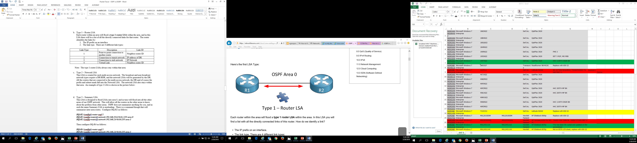

1. Type 2 – Network LSA

This LSA is created for each multi-access network. The broadcast and non-broadcast network types require a DR/BDR, and the network LSAs will be generated by the DR. All the routers that are connected to the multi-access network, the DR and of course the prefix and subnet mask fall into the Network LSA. The network LSA also stays within that area. An example of type 2 LSA is shown in the picture below:

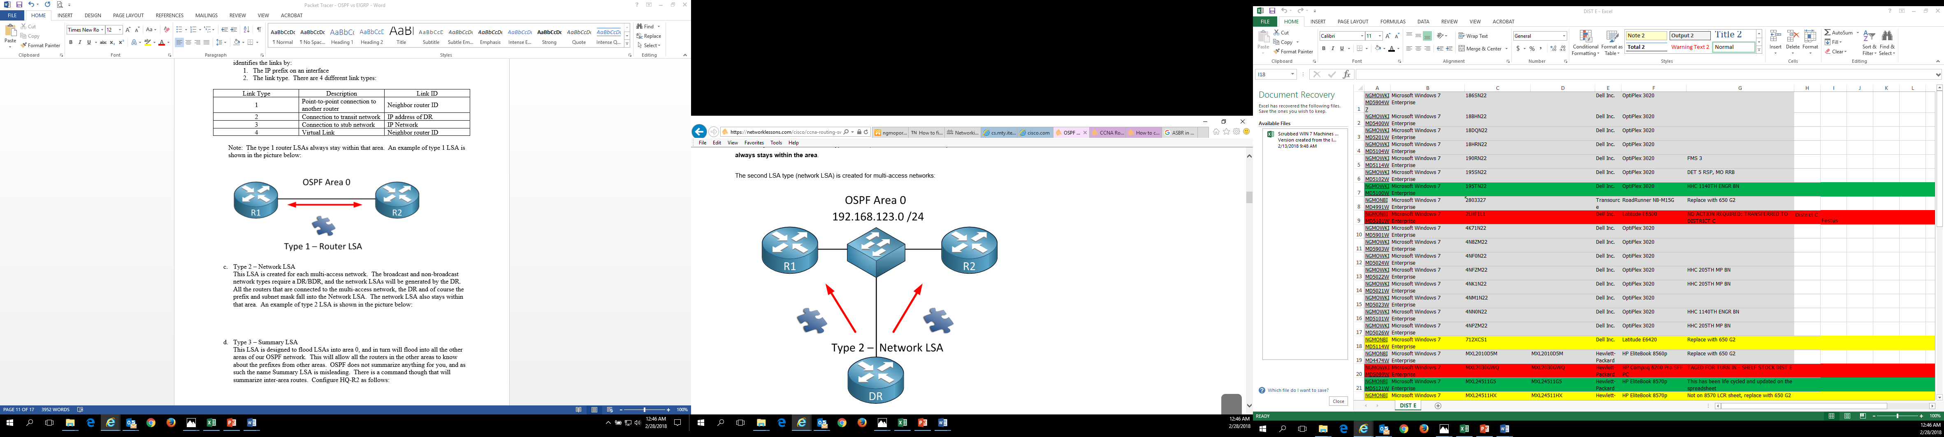

1. Type 3 – Summary LSA

This LSA is designed to flood LSAs into area 0, and in turn will flood into all the other areas of our OSPF network. An example of type 3 LSA is illustrated in the picture bellow:

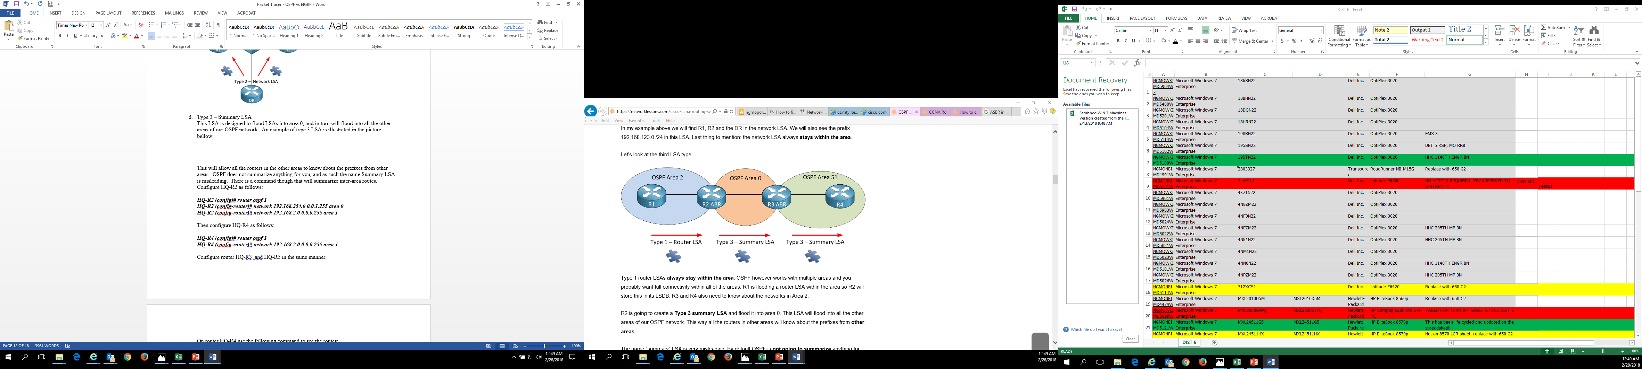

This will allow all the routers in the other areas to know about the prefixes from other areas. OSPF does not summarize anything for you, and as such the name Summary LSA is misleading. There is a command though that will summarize inter-area routes. Configure HQ-R2 as follows:

***HQ-R2 (config)# router ospf 1***

***HQ-R2 (config-router)# network 192.168.254.0 0.0.1.255 area 0***

***HQ-R2 (config-router)# network 192.168.2.0 0.0.0.255 area 1***

Then configure HQ-R4 as follows:

***HQ-R4 (config)# router ospf 1***

***HQ-R4 (config-router)# network 192.168.2.0 0.0.0.255 area 1***

Configure router HQ-R3 and HQ-R5 in the same manner.

On router HQ-R4 use the following command to see the routes:

***HQ-R4# show ip route ospf***

And also use the following command to see the summary in the LSDB:

***HQ-R4# show ip ospf database | begin Summary***

Now you can summarize the routes with type 3 summary LSAs using the following

command:

***HQ-R2 (config)# router ospf 1***

***HQ-R2 (config-router)# area 0 range 192.168.0.0 255.255.252.0***

Now verify the routes for HQ-R2:

***HQ-R4# show ip route ospf***

Then verify the routes for HQ-R4:

***HQ-R4# show ip ospf database | begin Summary***

Now instead of have multiple type 3 LSAs there is just a single LSA in the LSDB.

Another thing that can be done with OSPF and summarization is **external route**

**summarization.** This will be shown later on with type 5 LSAs. Two think that you

might want to keep in mind are:

1. You can create the summary only on the Autonomous System Border Router
2. A null0 entry will be created in the routing table for the summary route
3. Type 4 – Summary ASBR LSA

The Autonomous System Border Router LSA is used for the router that communicates outside its OSPF network with another networks such are a RIP network. What will happen is that a router will flip a bit in the router to identify itself as an ASBR. When an Area Border Router (ABR) receives this routers LSA it will create a type 4 summary ASBR LSA and flood it into area 0, and this LSA will then be flooded into the other areas so all OSPF routers know where to find the ASBR as shown in the below picture.

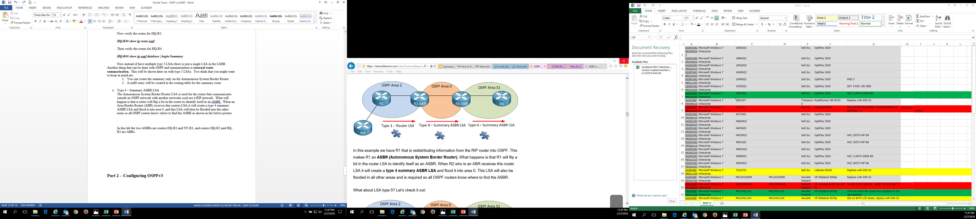

In this lab the two ASBRs are routers HQ-R1 and NY-R1, and routers HQ-R2 and HQ-R3 are ABRs.

1. Type 5 – Autonomous System External LSA

The below image is the same as the one above except that it now has a prefix added at the RIP router. This prefix will be redistributed into the OSPF, and the ASBR will take care of this and create a **type 5 external LSA** for this. The previous type 4 LSA is required to be able to locate the ASBR.

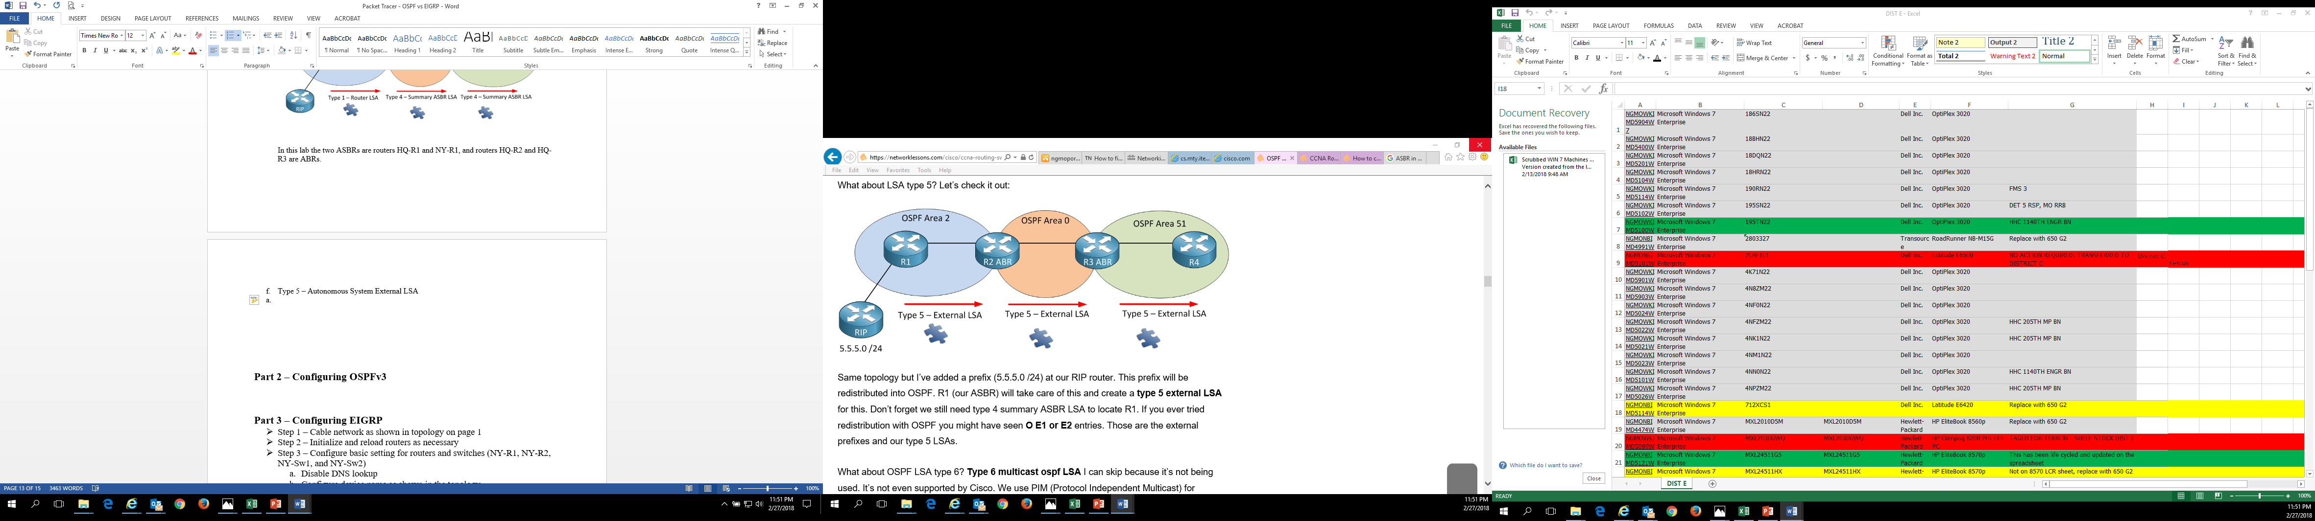

Now you can create an external route summarization by using the network command to advertise the prefixes on the loopback interfaces. An example is shown in the below picture:

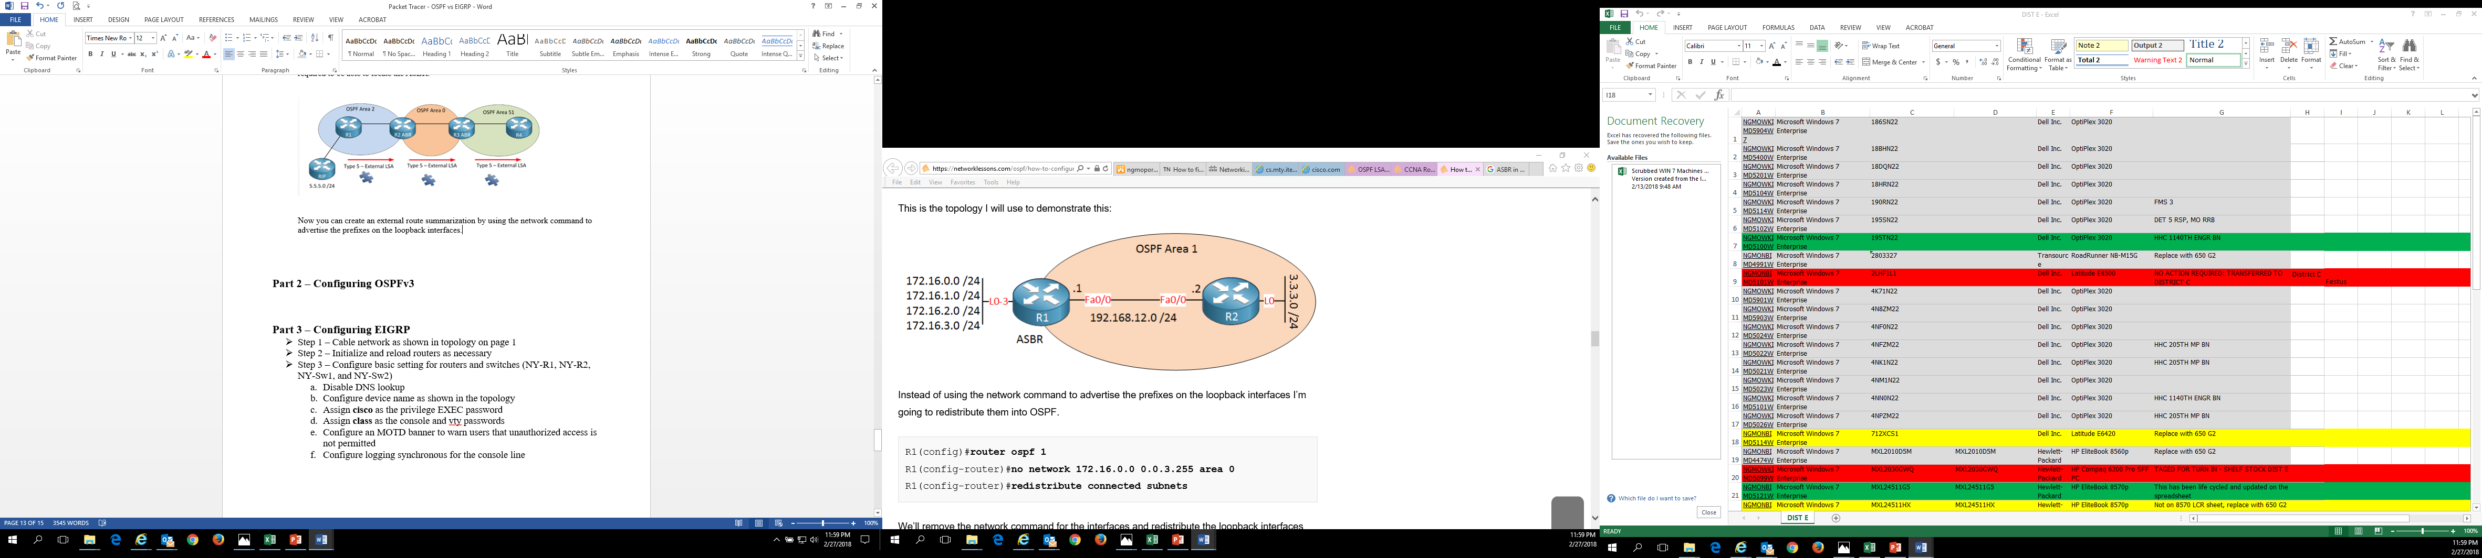

Instead of using network command to advertise the loopback interfaces you are going to redistribute them into OSPF as follows:

Create the following loopback address on HQ-R2:

***HQ-R2 (config)# interface Loopback 0***

***HQ-R2 (config-if)# ip address 172.16.0.0 255.255.255.0***

***HQ-R2 (config-if)# interface Loopback 1***

***HQ-R2 (config-if)# ip address 172.16.1.0 255.255.255.0***

***HQ-R2 (config-if)# interface Loopback 2***

***HQ-R2 (config-if)# ip address 172.16.2.0 255.255.255.0***

***HQ-R2(config-if)# interface Loopback 3***

***HQ-R2 (config-if)# ip address 172.16.3.0 255.255.255.0***

Now use the router ospf command to redistribute the loopback addresses into OSPF as

shown below:

***HQ-R2 (config)# router ospf 1***

***HQ-R2 (config-router)# redistribute connected subnets***

Now you can verify the routed subnets using the following command, notice that the

routes will show up as O E2 entries in the routing table:

***HQ-R4# show ip route ospf***

Display the LSDB to show the type 5 external LSAs:

***HQ-R4# show ip ospf database | begin Type-5***

To summarize the type 5 LSAs you can use the commands below:

***HQ-R2 (config)# router ospf 1***

***HQ-R2 (config-router)# summary-address 172.16.0.0 255.255.0.0***

That is how to use the type 5 external LSAs by using the summary-address command,

which is a different command compared to type 3 summary LSAs. Now verify the

summarized route:

***HQ-R4# show ip route ospf***

Instead of there being multiple type 5 external LSAs there is only one summarized type 5

LSA. By summarizing routes to condense multiple type 3 or type 5 routes into one

summarized route you will speed up the routing process because the router will have less

routes to look thru to find the right route.

1. Type 6 – Multicast OSPF LSA

The type 6 multicast OSPF LSA is not being used, and is not supported by Cisco. Cisco uses Protocol Independent Multicast for multicast configurations.

1. Type 7 – Not-so-stubby area (NSSA) LSA

The NSSA areas do not allow type 5 external LSAs, so as shown in the picture below type 7 NSSA LSAs are used to redistribute information from RIP into OSPF

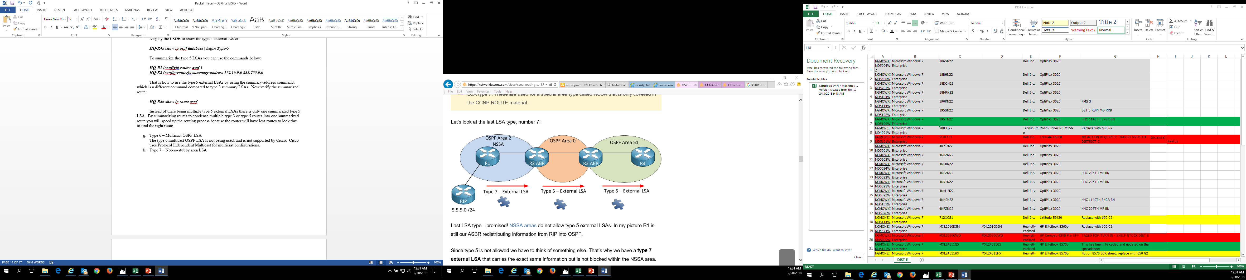

Since type 5 LSAs are not allowed in a NSSA area, so for this to work the ABR will take

the type 7 LSA and translate it into a type 5 LSA and flood it into all the other areas. The

Not-so-stubby area LSA is also known as **type 8 External LSA**.

* **Step 14** – Verify Connectivity Across All PCs in OSPFv2
  1. Use the ping command in command prompt on the desktop of the PCs to verify connectivity across all PCs using OSPFv2.
* **Step 15 –** Configuring OSPFv3

1. In using OSPF for IPv4 you were using OSPFv2. OSPF has been updated to be able to use IPv6 and is now called OSPFv3. Below is a sample topology for OSPFv3:

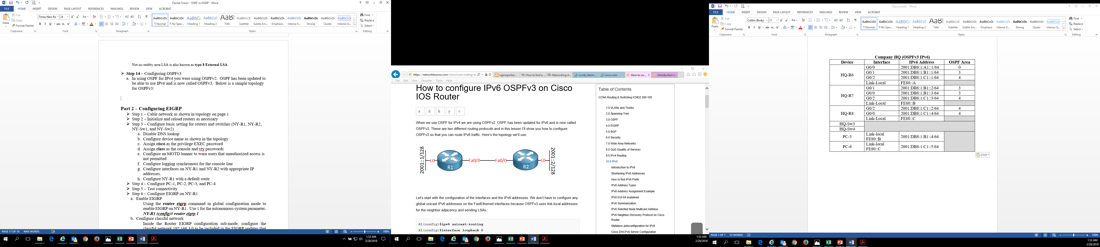

To be able to route on a Cisco router with IPv6 you need to use the following command below on all routers:

***HQ-R6 (config)# ipv6 unicast-routing***

1. Before you get into configuring OSPFv3 configure all the interfaces with the IPv6

address from above for the following routers, HQ-R6, HQ-R7, and HQ-R8. Below is the

command for configuring an IPv6 address on an interface.

***HQ-R6 (config)# interface GigabitEthernet 0/0***

***HQ-R6 (config-if)# ipv6 address 2001:DB8:1:A1::1/64***

***HQ-R6 (config-if)# ipv6 address FE80::A Link-local***

1. Now configure the rest of the interfaces on the routers using the above commands. Configure a Loopback address on router HQ-R6 as shown below:

***HQ-R6 (config)# interface Loopback 0***

***HQ-R6 (config-if)# ipv6 address 2001::1/128***

1. Now configure the below ipv6 address for Loopback interfaces on routers HQ-R7 and

HQ-R8:

|  |  |  |
| --- | --- | --- |
| **Router Name** | **Interface** | **IPv6 Address** |
| HQ-R7 | Loopback 0 | 2001::2/128 |
| HQ-R8 | Loopback 0 | 2001::3/128 |

1. To verify the Loopback interfaces and IPv6 address use the command below:

***HQ-R6# show ipv6 interface brief***

Note: When you type in the show ipv6 interface brief and no interfaces show up then

you need to go back and execute the IPv6 unicast routing command again.

1. For the Link-local address to show up on the GigabitEthernet ports you need to execute

the following command:

***HQ-R6 (config)# interface GigabitEthernet 0/0***

***HQ-R6 (config-if)# ipv6 enable***

***HQ-R6 (config)# interface GigabitEthernet 0/1***

***HQ-R6 (config-if)# ipv6 enable***

***HQ-R6 (config)# interface GigabitEthernet 0/2***

***HQ-R6 (config-if)# ipv6 enable***

1. Now verify that the link-local address show up on all the IPv6 interfaces.

***HQ-R6# show ipv6 interface brief***

1. Now we can get into configuring OSPFv3:

***HQ-R6 (config)# ipv6 router ospf 1***

***HQ-R6 (config-rtr)# router-id 6.6.6.6***

***HQ-R6 (config-rtr)# exit***

***HQ-R6 (config)# interface GigabitEthernet 0/0***

***HQ-R6 (config-if)# ipv6 ospf 1 area 0***

***HQ-R6 (config)# interface GigabitEthernet 0/1***

***HQ-R6 (config-if)# ipv6 ospf 1 area 3***

***HQ-R6 (config)# interface GigabitEthernet 0/2***

***HQ-R6 (config-if)# ipv6 ospf 1 area 4***

***HQ-R6 (config-if)# exit***

***HQ-R6 (config)# interface Loopback 0***

***HQ-R6 (config-if)# ipv6 ospf 1 area 0***

1. Now configure routers HQ-R7 and HQ-R8 the same way using the information from the addressing scheme above. Note that the Loopback interface on the routers correspond to the area the router is in.

|  |  |
| --- | --- |
| Router Name | RID |
| HQ-R6 | 6.6.6.6 |
| HQ-R7 | 7.7.7.7 |
| HQ-R8 | 8.8.8.8 |

1. You can use the **show ipv6 ospf neighbor** command to see your neighbor routes in the routing table. Use this command to verify the routes in the routing table:

***HQ-R6# show ipv6 ospf neighbor***

* **Step 16 –** Configure an IPv6 OSPFv3 Passive-Interface and Default Router

1. Just like in IPv4 you do not want hello packets being sent to the switches so you can use the following command on routers HQ-R7 and HQ-R8:

***HQ-R7 (config)# ipv6 router ospf 1***

***HQ-R7 (config-rtr)# passive-interface GigabitEthernet 0/0***

***HQ-R7 (config-rtr)# passive-interface GigabitEthernet 0/2***

1. Using the above command configure HQ-R8 with a passive interface.
2. Like IPv4 it is possible to set a default route in OSPFv3 for IPv6. The **default-information originate** command is what advertises the default route in IPv6. Now set the default route in OSPFv3 on router HQ-R6 using the following command:

***HQ-R6 (config)# ipv6 route ::/0 GigabitEthernet 0/0***

***HQ-R6 (config)# ipv6 router ospf 1***

***HQ-R6 (config-rtr)# default-information originate always***

1. Verify that the two routers are neighbors:

***HQ-R6# show ipv6 ospf neighbor***

Then check to see if a default route has been learned by router HQ-R3:

***HQ-R6# show ipv6 route ospf***

* **Step 17** - Verify Connectivity Across All PCs in OSPFv2 and OSPFv3

1. Use the ping command in command prompt on the desktop of the PCs to verify connectivity across all PCs using OSPFv2 and OSPFv3.

**Part 2 – Configuring EIGRP**

* **Step 1** – Configure basic setting for routers and switches (NY-R1, NY-R2, NY-Sw1, and NY-Sw2)
  1. Disable DNS lookup
  2. Configure device name as shown in the topology
  3. Assign **cisco** as the privilege EXEC password
  4. Assign **class** as the console and vty passwords
  5. Configure an MOTD banner to warn users that unauthorized access is not permitted
  6. Configure logging synchronous for the console line
* **Step 2** – Configure PCs in the EIGRP and EIGRP for IPv6 network
* **Step 3** – Test connectivity
* **Step 4** – Configure Interfaces on all routers with the IPv4 and IPv6

addresses from the addressing tables above and configure all IPv4 switches with a default gateway

* **Step 5** – Configure EIGRP
  1. Enhanced Interior Gateway Routing Protocol (EIGRP) is the other routing protocol that you will be configuring in this lab. EIGRP is a Cisco proprietary routing protocol and can only be used on Cisco equipment because vendors such as Juniper does not support it. EIGRP is considered a hybrid advanced distance vector protocol. EIGRP is one of the routing protocols you need to master if you want to pass the Cisco CCNA exam.

Configuring EIGRP is similar to configuring RIP such as the 1 after eigrp, is the Autonomous System number and has to be the same on all routers in your EIGRP network. The **no auto-summary** command is used because by default EIGRP behaves like a classful routing, but it needs to behave like a classless.

Now lets start our configuring of EIGRP with configuring EIGRP between router NY-R1 and NY-R2 using the following command:

***NY-R1 (config)# router eigrp 1***

***NY-R1 (config-router)# no auto-summary***

***NY-R1 (config-router)# network 209.165.200.4***

***NY-R1 (config-router)# network 192.168.4.0***

***NY-R2 (config)# router eigrp 1***

***NY-R2(config-router)# no auto-summary***

***NY-R2 (config-router)# network 192.168.4.0***

***NY-R2 (config-router)# network 192.168.6.0***

***NY-R2 (config-router)# network 192.168.7.0***

* 1. Now configure routers NY-R3 and NY-R4 using the same commands above.
  2. You can use the **show ip eigrp neighbors** command to verify working EIGRP neighbor adjacency. Now verify that the routers have become neighbors by using the following command:

***NY-R1# show ip eigrp neighbors***

***NY-R2# show ip eigrp neighbors***

* 1. You can also view the routing table by using the command below:

***NY-R1# show ip route eigrp***

* 1. The metrics in EIGRP are not as easy to work with as they are in OSPF because the numbers in EIGRP are very large. To find why data was routed a certain way in EIGRP you can view the eigrp topology table using the following command:

***NY-R1# show ip eigrp topology***

Note: This is an important command to know.

* 1. There are two important numbers in the ip eigrp topology table, they are:

1. The feasible distance
2. The advertised distance

If the advertised distance is lower than the feasible distance of the successor then it is called the **feasible successor**.

If the feasible successor is not showing up in the routing table you can activate load balancing so that the feasible successor can also be used, the command for this is as follows:

***NY-R1 (config)# router eigrp 1***

***NY-R1 (config-router)# variance 3***

You need to use the variance command 3 to set the multiplier. Now check the routing table:

***NY-R1# show ip route eigrp***

* **Step 6 –** Configure a EIGRP Passive-Interface

a. To advertise your network without sending EIGRP packets on the interface and forming EIGRP neighbors you can use the **passive-interface** command as shown below:

***NY-R1 (config)# router eigrp 1***

***NY-R1 (config-router)# passive-interface Serial 0/1/1***

1. Now you can set routers NY-R3 and NY-R4 to have a passive-interface facing the switches.
2. To reset the EIGRP neighbor adjacency on NY-R1 you can use the following command:

***NY-R1# clear ip eigrp neighbors***

1. Now take a look at the neighbor adjacency on NY-R1:

***NY-R1# show ip eigrp neighbors***

* **Step 7** – EIGRP K Values Formula

1. EIGRP uses different K values to determine the best path to each destination as shown below:
2. Bandwidth (K1)
3. Load (K2)
4. Delay (K3)
5. Reliability (K4)
6. MTU (K5)

These K values are only numbers to scale numbers in the metric calculation. To see what K values are enabled or disabled by default use the following command:

***NY-R1# show ip protocols***

1. You can use the following command to view the bandwidth:

***NY-R1# show interfaces GigabitEthernet 0/0***

Bandwidth is a static value and can be changed by using the bandwidth command. Keep in mind this doesn’t change the actual bandwidth of the interface, but rather is only used to influence routing protocols like EIGRP. To change the bandwidth of an interface you can use the following command:

***NY-R1 (config)# interface GigabitEthernet 0/0***

***NY-R1 (config-if)# bandwidth 500***

Note: You can set the bandwidth between 1 and 10000000.

Now if you use the show interfaces GibabitEthernet 0/0 command you can see how the bandwidth has changed. Now change the bandwidth on router NY-R2 port GigabitEthernet 0/0 to 500.

1. Delay reflects the time it will take for packets to cross the link in a static value. Cisco has delay values for the different types of interfaces. You can view the delay value as follows:

***NY-R1# show interfaces GigabitEthernet 0/0***

To change the delay value you can change it using the following commands:

***NY-R1 (config)# interface GigabitEthernet 0/0***

***NY-R1 (config-if)# delay 50***

Now if you use the show interfaces GibabitEthernet 0/0 command you can see how the delay value has changed.

Now change the delay value on router NY-R2 port GigabitEthernet 0/0 to 50.

1. Reliability means that you do not have any issues on the physical data-link layer, and if you are having issues the reliability value will decrease. Since this is something that can change it is a dynamic value.
2. Maximum Transmission Unit (MTU) is being exchanged between EIGRP neighbors, but is not used for the metric calculation. Now by default only K1 and K3 are enabled, and K2 and K4 are not normally used. Therefore only bandwidth and delay are used in this formula. The shortened formula is as follows:

**Metric = bandwidth (slowest link) + delay (sum of delays)**

Now the extended formula is as follows:

$$Metric=(\frac{{10}^{7}}{minimum bandwidth)}*256+\left(sum of delays\right)*256$$

* **Step 8** – Configure EIGRP Route Summarization
  1. The best thing about EIGRP and summarization is that it is easy to do, and can be done on the interface-level. Now you can view the routing table to see how man routes there currently are:

***NY-R1# show ip route eigrp***

Now to create a summary route use the following commands:

***NY-R1 (config)# interface GigabitEthernet 0/0***

***NY-R1 (config-if)# ip summary-address eigrp 1 192.168.4.0 255.255.252.0***

By using the **ip summary-address eigrp** command to specify the summary the routing table should now show the summarized route. Now use the command to view the routing table to see the new summarized route:

***NY-R1# show ip route eigrp***

1. The three networks that existed now should only show two networks. Now when you advertise a summary route the router advertising the summary will use the lowest metric of all networks that fall within the range of the summary, and that is the one it will use for the summary. However it is possible to manually set the metric for each summary and the following commands shows how to do that:

***NY-R1 (config)# router eigrp 1***

***NY-R1 (config-router)# summary-metric 192.168.4.0 255.255.252.0 100000 10 255 0 1500***

Now the summary-metric requires you set the following:

1. The bandwidth
2. The delay
3. The Reliability
4. The Load
5. And the MTU

Now use the command to view the routing table:

***NY-R1# show ip route eigrp***

* **Step 9** – Configure EIGRP Default Network Route

1. There are two methods to setting a default route, they are:
2. Create a static route and advertise it into EIGRP
3. Flag an EIGRP route as the default network

Show the eigrp portion of the show run command as follows on routers NY-R1 and NY-R2:

***NY-R1# show run \ section eigrp***

1. Now set a static default route using the commands below:

***NY-R1 (config)# ip route 0.0.0.0 0.0.0.0 Serial 0/1/1***

***NY-R1 (config)# router eigrp 1***

***NY-R1 (config-router)# network 0.0.0.0***

With EIGRP you can use the network 0.0.0.0 command to advertise this network. Normally you can only use the network command to advertise networks to interfaces, but EIGRP makes an exception for this default route. Now show the default route portion of the routing table using the command below:

***NY-R1# show ip route eigrp | begin 0.0.0.0***

1. Now we will take a look at the other method of forming a default route, and choose whichever one works best for you. With the second version of default route, it can be a bit tricky because you use the ip default-network command to tell the EIGRP routers that this is a network of last resort, which means that the router can use it as a default route as shown below:

***NY-R1 (config)# router eigrp 1***

***NY-R1 (config-router)# ip default-network 209.165.200.4***

The default-network command is a global command and not an EIGRP command. Now lets look at the eigrp topology to see what happened:

***NY-R1# show ip eigrp topology 209.165.200.4***

Also the **show ip route** command shows you the routing table as well, and next to the * is a “D” which represents EIGRP. So D* represents a default route.

* **Step 10** - Verify Connectivity Across All PCs in EIGRP
  1. Use the ping command in command prompt on the desktop of the PCs to verify connectivity across all PCs using EIGRP.
* **Step 11** – Configure EIGRP for IPv6
  1. Before we get into configuring routers NY-R1, NY-R5, NY-R6, and NY-R7, if you have not issued the ipv6 unicast-routing command on these routers do that now.
  2. Now we can configure the routers with EIGRP for IPv6. EIGRP is the most suitable routing protocol for IPv6, even though the configuration is a little different. Since you have already configured the interfaces with IPv6 addresses the next thing we will do is enable a GigabitEthernet port for IPv6. Use the command to do this:

***NY-R1 (config)# interface GigabitEthernet 0/1***

***NY-R1 (config-if)# ipv6 enable***

With enabling IPv6 on the interface it will generate on IPv6 link local address.

* 1. Now verify that the interfaces that are being used have both the link-local that was generated, and the global unicast address:

***NY-R1# show ipv6 interface brief***

* 1. Below is the commands to enable EIGRP for IPv6:

***NY-R1 (config)# ipv6 router eigrp 1***

***NY-R1 (config-rtr)# router-id 1.1.1.1***

***NY-R1 (config-rtr)# no shutdown***

***NY-R1 (config-rtr)# exit***

***NY-R1 (config)# interface GigabitEthernet 0/1***

***NY-R1 (config-if)# ipv6 eigrp 1***

* 1. Now configure router NY-R5, NY-R6, and NY-R7 with EIGRP for IPv6 using those commands.
  2. Next use the show ipv6 eigrp neighbors command to verify the adjacency.
* **Step 12** - Verify Connectivity Across All PCs in EIGRP and EIGRP for IPv6

1. Use the ping command in command prompt on the desktop of the PCs to verify connectivity across all PCs using EIGRP and EIGRP for IPv6.

* **Step 13** - Verify Connectivity Across All PCs in EIGRP and EIGRP for IPv6

1. Use the ping command in command prompt on the desktop of the PCs to verify connectivity across all PCs using OSPF and EIGRP for both IPv4 and IPv6.